Tips for WebEx Presenters

Sharing your screen
The host must start the WebEx and if they will not be presenting, they can easily assign presenter controls to other meeting participants.
Once you’re logged in, you can verbally request presenter controls from the host. Once you receive the presenter control you can select the share my desktop button in the center of your screen (show below).

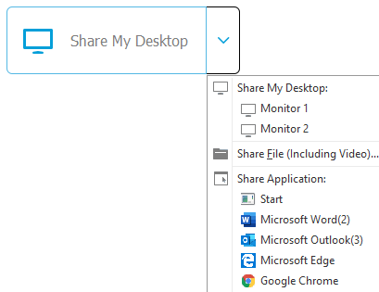

If the host intends to leave the meeting under the control of another participant, they can designate that person as the “host.” Pro tip: make the intended new host the presenter first to ensure no issues and once they’re successfully sharing their screen go ahead and change their role to host before leaving the meeting.
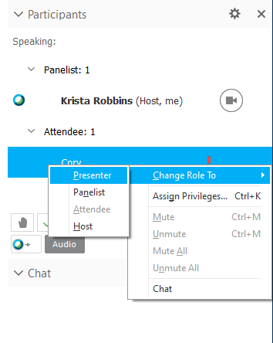
To change participant role to presenter or host, right click their name and select “change role to.” You can switch between presenters as needed by taking back control and then reassigning.

View meeting participants:

Hover your mouse over the “You are sharing your desktop” bar on the top middle of your screen and select “Participants” from the drop down. Note: on some WebEx sessions this may appear automatically on the right side of the presentation. Pro tip: If you have to open the participant box this will appear to viewers as a yellow box so be mindful it is not covering content you’re sharing.

Checking the chat box for questions or comments from meeting participants

Meeting Host Privileges
Hosts have more controls and can mute/unmute meeting participants throughout the session. They can have all participants muted upon entry (prior to meeting start), they can give attendees access to use video conferencing and they can see polling results. Pro tip: if the host mutes a participant, only they can unmute them. Ideally all participants will mute themselves upon entry.

Mute All Participants or Mute Individual Attendees
- Open the Participant panel
- Select a participant or call-in user, right click
- Select Mute to mute individual or Mute All to mute all participants
*Note: Use Unmute or Unmute All to disable mute feature
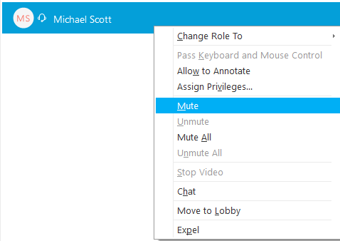

Audio disruptions
To identify which participants’ connection is causing the feedback look for the “sound icon” next to participants names (shown below). When you’re consistently seeing this next to the same attendee, mute them. You may have to do this for multiple attendees (they can use “raise hand” or chat box).

Turn Off and On Video Participation
- Scroll to the top Navigation bar for the WebEx
- Select either “Meeting” or “Options”
- Under Meeting Options, General, Select Allow all participants to turn on video

